# April 15, 2021

# Pastor Gabriel Wee

# Toronto Lifespring Christian Fellowship

Dear Pastor Wee,

# Below is the OM Greece refugee ministry report.

The COVID-19 pandemic has affected many aspects of our lives. All the refugee camps imposed tighter restrictions to help contain the spread of the virus in the camps. People were not allowed to leave the camps, and numbers of volunteers were also limited. It was done to help protect the refugees, because the shelters they live in are in very close proximity to each other.

Only 40% of our OM workers (and other companies) are allowed to go out and work either in the office or in the ministries, but they have to take extra care using PPE.

# The effect of COVID on the refugee ministry

We had to adjust our activities and programs according to the situation. That means our normal programs in the Malakasa refugee camp were affected. For safety reasons, the government stepped in and made sure there was enough food available for the residents of the camps, so we did not provide any more food there.

But there are other groups of people living outside the refugee camps who relied on foodbanks and feeding programs around the city. The lockdown forced the foodbanks and feeding programs to shut down, and the people who relied on such programs, no longer have access to food and clothes.

# Our response

In the end of September, Gabby and Vasilis flew to Lesbos to evaluate the situation in the new refugee camp, after the previous camp was completely burnt down. Although there were restrictions due to the pandemic, we were given access into the camp. We worked with Rhema and gave breakfast packs to over 1,200 people. After talking with various officials and workers there, we felt no need for OM to work in the new camp, because there are enough agencies working in the camp.

# Refugee Ministries during Lockdown

# 

We are limited, but we continue to provide help to the refugees. Given below are some of the activities and projects we did. Some of them, like the food baskets will continue even in the coming months.

* Despite the restrictions, we were able to give supplies to 3,000 people since September. These are the people that live in the city and did not have access to food because of the closure of feeding ministries and projects. Each of the families are provided with a food basket that should last for a month.
* 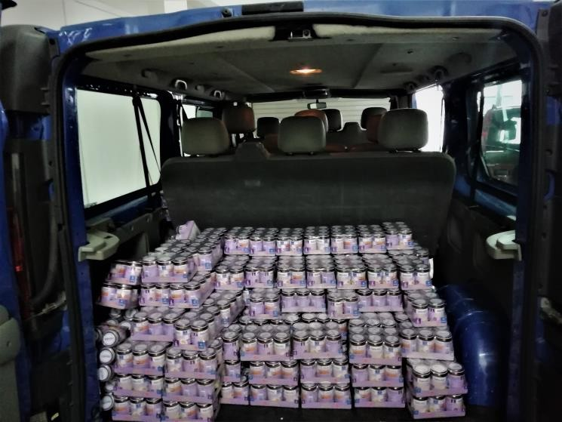Apart from the food packages, we distributed 9,600 baby food packs to children between the ages of 6 – 24 months.
* We were able to provide 400 reusable face masks to some of the refugees. These masks were bought from two members of the new Farsi fellowship who started a sewing business producing masks.
* OM Greece also helped provided Malakasa refugee camp with 150 carpets during the winter months. These carpets were given to the refugees to place on the floor of their container to help keep their accommodation warm.
* 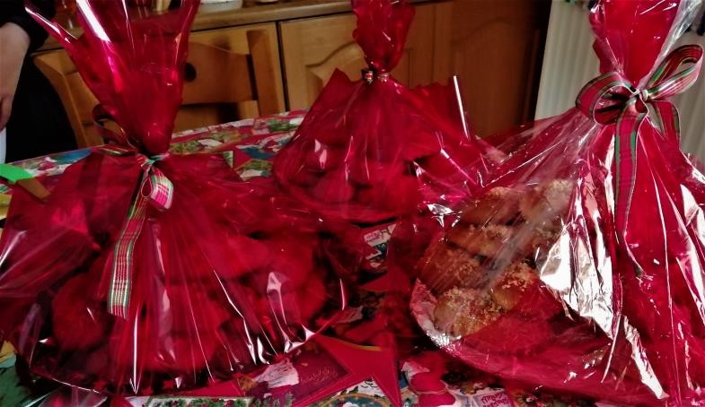During the Christmas period, OM supplied 350 teddy bears to the camps to be given to the children in the camp. In Athens, we made Christmas packages with cookies to hand out to some of the regular families that we have developed relationships with. Many of them are now part of the Farsi Fellowship we started in 2020.
* We also provided some health-related assistance. One couple’s dental costs were covered because they could not afford it. A man in the camp had issues with his spine. The doctors told him to get a special mattress. The camp management could not provide the mattress, so OM covered the cost of the mattress. We also assisted a child in the camp that needed a brace for his back due to an injury.
* Accommodation for a persecuted family – A family of 4 was rescued from Malakasa camp after their accommodation was set on fire three times by Muslims. We are currently renting a small apartment for them. The husband went back to the refugee camp and started a fellowship with five people, which has now grown to over 60 people.

**Online services**

During the lockdown, we did not stop the English classes. 85 students continued to learn English online. We also continued our Sunday services (fellowship) online. Some of these students and Christians do not have access to wifi or internet, so we provide them with sim cards so they can continue their classes and join us for Sunday service.

**Impact of our work**

We are happy that we can be the hands and feet of Jesus in some ways to some of these refugee families. We are also pleased that through the work we do and the love we show, some of these people have responded positively to the gospel of Jesus Christ.

As a result of working with the refugees, we have started a Farsi Fellowship with over 60 people, a Dari fellowship with close to 12 people, and an Arabic Fellowship with about 11 people.

Last week, one team member said that 6 new people joined the fellowship, because he talked to them during the food distribution and invited them to the online fellowship.

**We thank you for enabling us to be the hands and feet of Jesus to those who need help.**

OM Greece Team